Birla Institute of Technology & Science, Pilani Work Integrated Learning Program
2024-2025

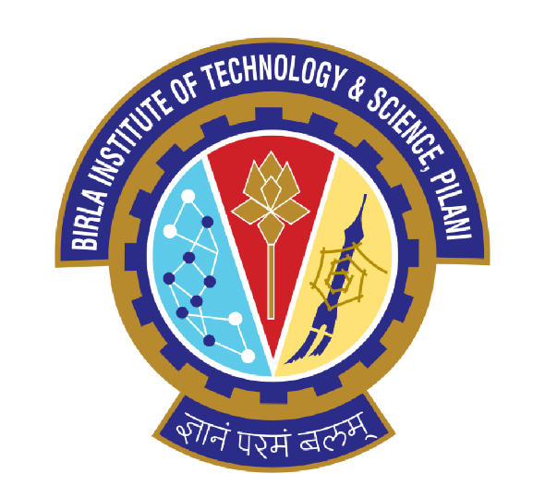

Submitted by:
Name: Mukund Vishwas Chavan
Course: Data Storage Technology and Networks
Student ID: 01011

Peta-scale Distributed Unified Storage Solution Design

Table of Contents

Chapter / Section | Title
1 | Executive Summary and Requirement Analysis
1.1 | Project Overview
1.2 | Key Architectural Drivers (Scale, Consistency, Performance, Availability)
2 | System Architecture and Component Design
2.1 | Core Architectural Model: Geo-Distributed Software-Defined Storage (SDS)
2.2 | Component Breakdown and Functionality
2.2.1 | Data Storage Tiers
2.2.2 | Service Layers
2.3 | Access Protocols and Justification
3 | Storage Planning, Provisioning, and Budget Management
3.1 | Capacity Planning and Sizing
3.2 | Backup and Disaster Recovery Allocation
3.3 | Budget Optimization: Tiering and Thin Provisioning
4 | Data Management: Consistency, Replication, and De-duplication
4.1 | Consistency Model: Local and Global Quorum Mechanisms
4.2 | Replication Scheme: Synchronous and Asynchronous Approaches
4.3 | De-duplication Mechanism: Variable-Block Content-Aware Model
5 | Storage Virtualization and Abstraction Layer
5.1 | Scope of Virtualization
5.2 | Global Namespace and Hardware Abstraction
5.3 | Automated Tiering and Provisioning
5.4 | Use Case: Disaster Recovery and Failover Automation
6 | Conclusion and Future Scalability
6.1 | Summary of Solution Benefits
6.2 | Future Roadmap for Exabyte-Level Expansion

Chapter 1: Executive Summary and Requirements Analysis
1.1 Project Overview
This project involves developing a Peta-scale Distributed Unified Storage System designed to handle satellite imagery, derivative geographic data, and processed metadata. The main goal is to provide continuous 24/7 worldwide accessibility with uniform system efficiency while ensuring data integrity and coherence across every access point.
1.2 Key Architectural Drivers
- Scale: System capacity should reach petabytes, with potential scalability up to the exabyte range.
- Availability: Must provide uninterrupted 24/7 global accessibility and disaster recovery capability up to the last recorded checkpoint.
- Performance: Maintain consistent low-latency performance across global regions through WAN optimization.
- Consistency: Data must remain coherent and free of duplication across all distributed storage nodes.
- Budget: The infrastructure must support cost-efficient deployment using tiered storage and resource abstraction mechanisms.
Chapter 2: System Architecture and Component Design
2.1 Core Architectural Model: Geo-Distributed Software-Defined Storage (SDS)
The proposed framework utilizes a globally distributed hybrid storage architecture controlled by a Software-Defined Storage layer. This approach separates the control plane (for orchestration and management) from the data plane (handling physical storage), allowing independent scalability of each layer.
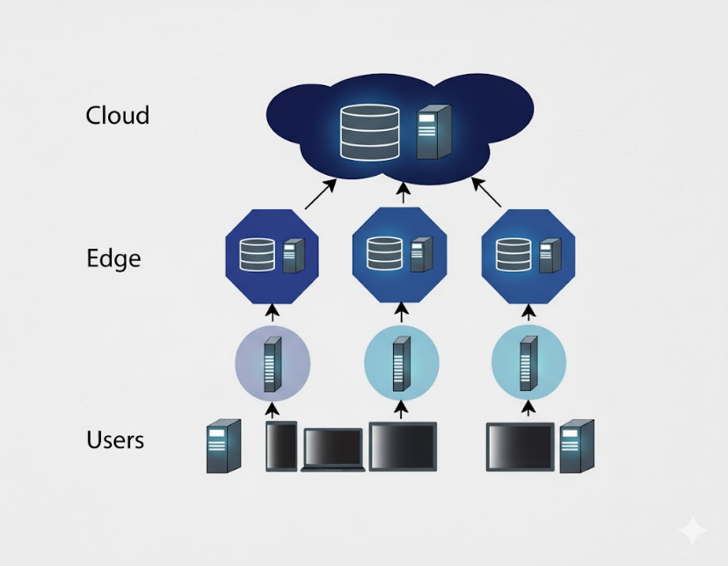
2.2 Component Breakdown and Functionality
2.2.1 Data Storage Tiers
Component | Data Type | Physical Storage | Role and Function
Tier 1: Hot Metadata | Indexes, landmark updates, current processing tasks | NVMe / High-Speed SSDs (Local to Data Centres) | Provides low-latency and high-IOPs operations with strong transactional reliability (ACID).
Tier 2: Warm Object | Raw Images (last 90 days), active map grids, processed artifact lists | Mid-range SSD/HDD hybrid (SAS/SATA) | Offers a balanced ratio of capacity and throughput, forming the working dataset for analytics.
Tier 3: Cold Archive | Historical images, complete daily backups | High-density HDDs / Tape gateways | Lowest cost per GB, designed for long-term archival, bulk sequential reads, and durability.

2.2.2 Service Layers
- Global Load Balancer (DNS/Anycast): Routes client requests to the nearest active data center, ensuring consistent global response times.
- Storage Access Gateway: Handles protocol conversion (e.g., S3 ↔ DFS), initial authentication, and directs the request to the appropriate storage tier.
- Global Metadata Service (GMS): A fault-tolerant cluster (based on Raft/Paxos) that maintains metadata, replication mapping, and de-duplication indexes—central to ensuring data coherence.

2.3 Access Protocols and Justification
Data Type | Access Protocol | Justification
Raw Satellite Images (WORM) | RESTful API (S3-compatible) over HTTP/S | Ideal for large-scale object storage, providing high throughput and seamless integration with cloud and CDN systems.
Processed Indexes / Metadata | POSIX / NFSv4 via DFS Layer | Required for applications that demand file-level consistency, locking, and frequent small updates.
Data Processing Applications | FUSE / Client Library | Enables low-overhead, high-performance direct access to distributed data storage fabrics.

Chapter 3: Storage Planning and Provisioning
3.1 Capacity Planning and Sizing
The solution targets peta-scale storage, ensuring redundancy and disaster recovery across three global data centers (DCs).
- Local Replication Factor: To protect against node or disk failures within a DC.
- Geo-Replication Factor: Maintains complete data copies across all three DCs.
- Total Storage Requirement: Accounts for both active replication and backup allocations.

3.2 Backup and Disaster Recovery Allocation
Daily full backups are maintained for seven days using content-aware de-duplication to reduce redundancy. This ensures compliance with the “previous day recovery” requirement while optimizing storage efficiency.

3.3 Budget Optimization (Tiering and Thin Provisioning)
- Tier 1 (SSD/NVMe): Allocated for critical metadata (~10% of total data).
- Tier 3 (HDD): Stores long-term historical data (~60% of capacity).
- Thin Provisioning: Initially, only partial storage is deployed, expanding as usage grows to minimize upfront costs (CAPEX).

Chapter 4: Data Management — Consistency, Replication, and De-duplication
4.1 Consistency Model
The system ensures global data reliability through a combination of strong local consistency and global quorum consensus.
- Local Consistency: Managed by Raft/Paxos-based distributed algorithms; a write is committed only after a majority of local nodes acknowledge it.
- Global Quorum (W+R > N): Ensures overlap between read and write operations across three replicas, maintaining “read-your-writes” integrity worldwide.
4.2 Replication Scheme
Local Replication: Synchronous triple replication within each DC for resilience.
Geo-Replication: Asynchronous updates between global DCs ensure near-real-time synchronization and disaster recovery capability.
Cloning: Maintains identical datasets across all sites to enhance performance and eliminate latency from intercontinental data transfers.
4.3 De-duplication Scheme
A content-aware, variable-block post-process de-duplication system is implemented:
- Primary Enforcement Point: During initial data ingestion, where only unique data blocks are stored.
- Backup Enforcement Point: Applied to historical backups, significantly reducing backup size and improving cost efficiency.

Chapter 5: Storage Virtualization and Abstraction
5.1 Scope
Storage virtualization plays a crucial role in simplifying the management of geo-distributed and heterogeneous storage hardware (such as NVMe, SSD, and HDD). It masks underlying hardware complexities and presents a single, cohesive interface to users and applications.
5.2 Global Namespace
Applications view a uniform directory (e.g., /satellite/regionX/imageY.tiff) irrespective of physical location. The SDS software dynamically maps to the closest consistent data replica.
5.3 Automated Tiering and Provisioning
The system automatically relocates frequently accessed (“hot”) data to faster tiers and archives infrequently used (“cold”) data to cost-efficient media, maintaining optimal performance and cost balance.
Automated Tiering: The virtualization layer continuously analyzes access frequency and dynamically relocates data. Frequently accessed (“hot”) metadata is migrated to high-speed Tier 1 (NVMe), while infrequently accessed (“cold”) data is shifted to Tier 3 (HDD). This mechanism maintains performance for active datasets and optimizes cost for archival data, ensuring balanced resource utilization.
Thin Provisioning: In this approach, physical storage space is allocated only when data is truly written. This minimizes over-provisioning and capital expenditure by allowing storage capacity to scale gradually based on actual usage requirements.
5.4 Disaster Recovery and Failover
In case of data center failure, the system auto-remaps namespace references to the nearest active site, enabling uninterrupted access and transparent recovery.

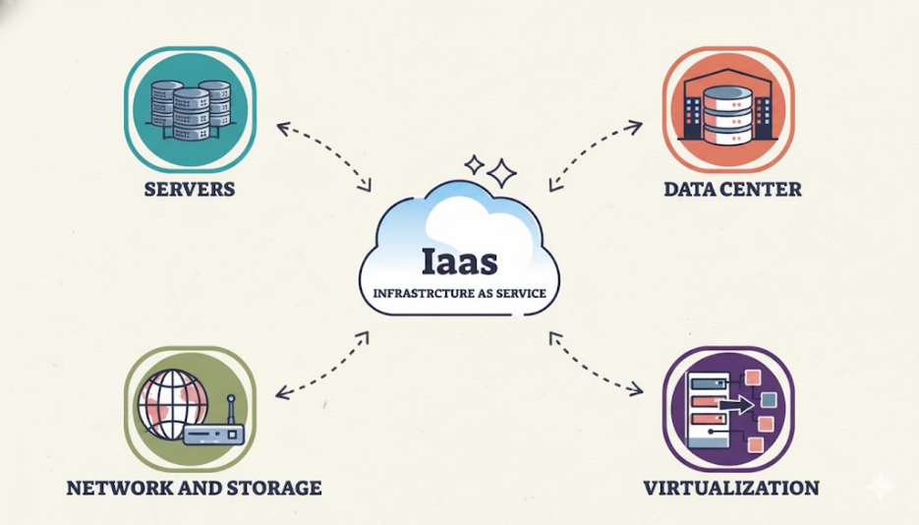

Chapter 6: Conclusion and Future Scalability
6.1 Summary of Solution Benefits
Requirement | Solution Benefit | Key Technology Used
Peta-scale Capacity | Cost-efficient large-scale storage through tiered commodity hardware | SDS pooling, high-density HDDs
24/7 Global Access | Low-latency, uninterrupted access from nearest replica | Geo-distributed active-active setup
Consistency | Guaranteed coherence and data reliability globally | Quorum-based consistency (W+R>N), Raft/Paxos
Disaster Recovery | Real-time recovery far beyond daily checkpoint | Asynchronous multi-site replication, auto failover

6.2 Future Scalability Roadmap
- Horizontal Scaling: Add new nodes or data centers seamlessly as capacity or performance demands grow.
- Adoption of New Media: Future-proofing for advanced storage technologies like QLC NAND or next-gen NVMe.
- Erasure Coding Transition: Transitioning archival tiers to erasure-coded formats (e.g., 8+4, 10+2) for efficient exabyte-scale expansion with minimal redundancy overhead.

